**Case Study 6**

**Task 1: User Interface Design**

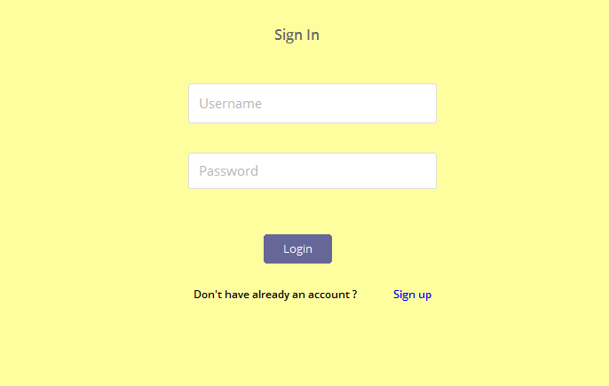Login Form

Registration Form

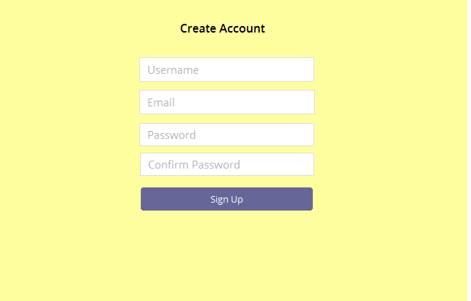

Ordering Form

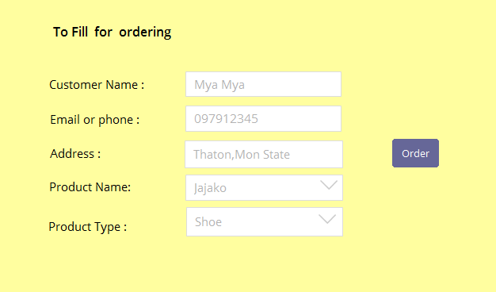

Product Management

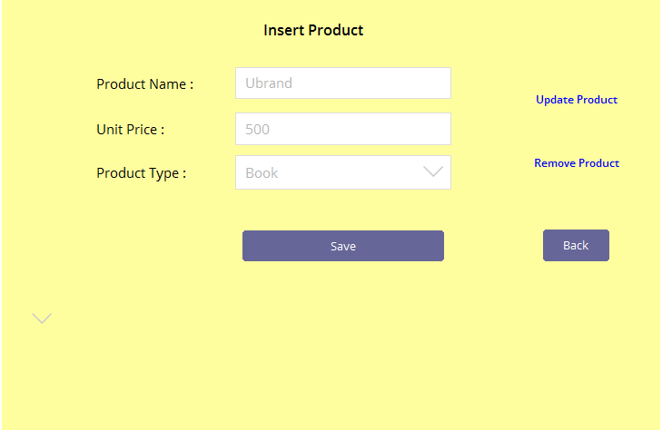

Product Information

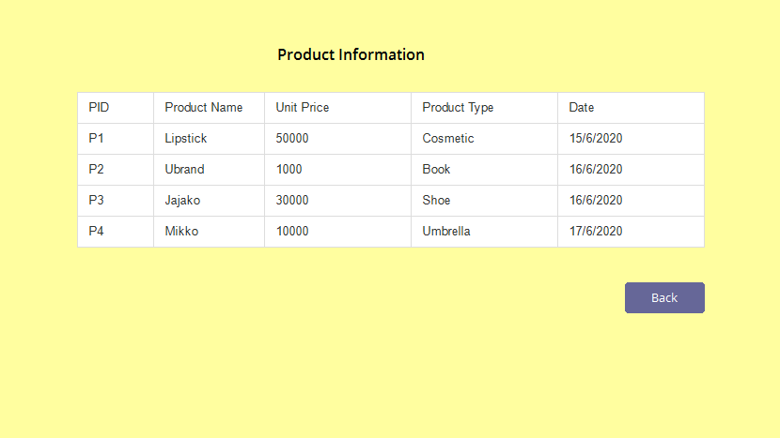

Order Report

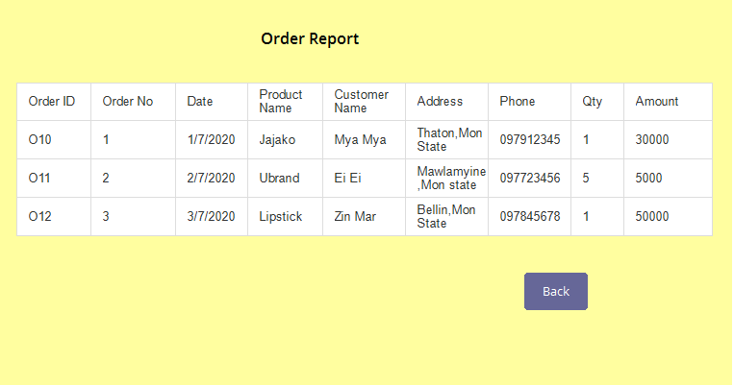

Delivery Information

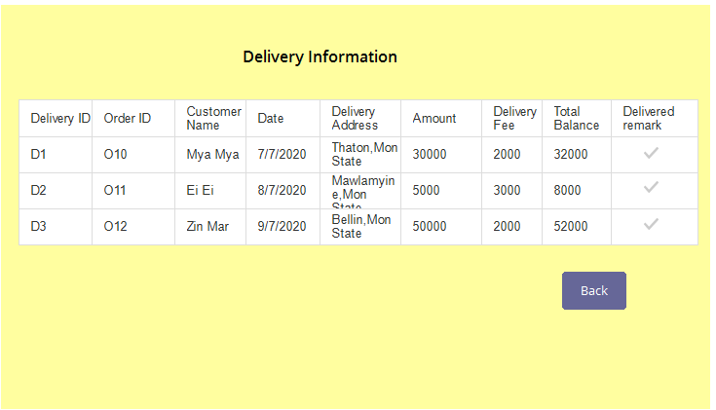

**Task 2: Development vs Deployment Plan**

This is the most important part for software development. The system goals define the expected project results together with the required development constraints. Information may be extracted from the project proposal and project requirement specification and completed, if required. In the development plan, considered the following various categories of project:

* Functional goals
* Strategic goals
* Technological goals(tools, methods)
* Quality goals
* Other goals(usability, portability)
* Time
* Cost

Before we hand over the project we need to justify the system requirements so that the client can run the system without any obligations and dissatisfactions. For that below is our requirements:

Software requirements

* Operating System: Windows ( 7, 8, 8.1, 10) or Mac or Linux
* Database Management System: MySql
* IDE (Integrated Development Environment): Eclipse
* Other: Postman , Spring Boot Framework

Hardware Requirements

* RAM: Minimum 2GB or higher.
* HDD: Minimum 50 GB.
* Processor: Intel core i3

**Task 3: Testing type**

Functional Testing:

* Unit Testing
* Integration Testing
* System Testing
* Interface Testing
* Regression Testing
* Beta/Acceptance Testing

Non-functional Testing:

* Performance Testing
* Load Testing
* Stress Testing
* Volume Testing
* Security Testing
* Compatibility Testing
* Install Testing
* Recovery Testing
* Reliability Testing
* Usability Testing
* Compliance Testing
* Localization Testing

**Task 4: Test Plan**

Test 1

* Test Title: Login Form
* Test Data: Users need to click Login fort for entering the system.
* Expected Result: It will redirect to login form.

Test 2

* Test Title : Registration form
* Test Data: Users need to click sign up for registration.
* Expected Result: System will register the users.

Test 3

* Test Title: Ordering Form
* Test Data: Users need to click Ordering Form for order.
* Expected Result: System will redirect to order form where customer fill out the form and place an order.

Test 4

* Test Title : Product Management
* Test Data: Users need to click Product Management for managing product.
* Expected Result: It will redirect to admin product management panel where admin can update, delete product.

Test 5

* Test Title : Order Report
* Test Data: Admin or Delivery staff need to click Order Report for viewing order.
* Expected Result: System will view all the records of the order.

Test 6

* Test Title : Delivery Information
* Test Data: Admin or Delivery staff need to click Delivery Information for viewing delivery record.
* Expected Result: System will view all the records of delivery.